Mag wheels available
- May 2013
15” & 16” Wheels

EMR 521 EMR 522 QS20F QS20F QS5037S
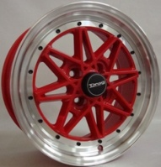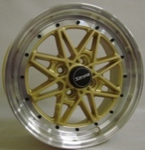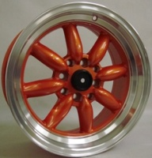
QS5037S QS5037S QS5612 QS028B QS028R
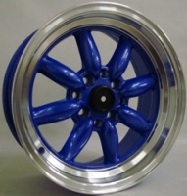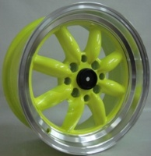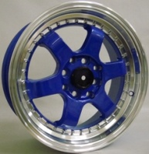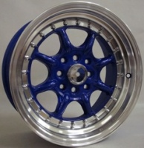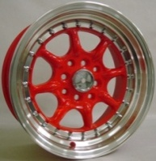
QS5037F QS5037F QS5037F 309 308
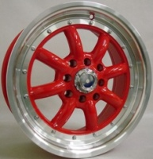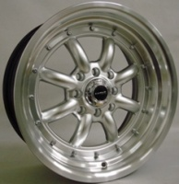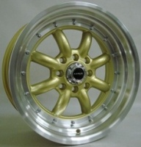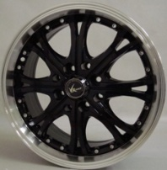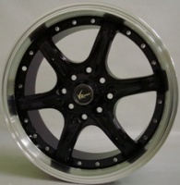
CWS679SG CWS679S CWS679BG CWS779S CWS779R
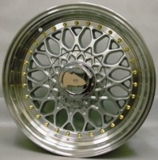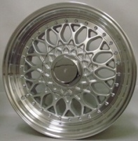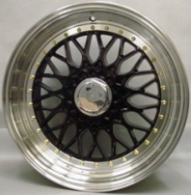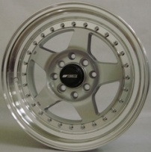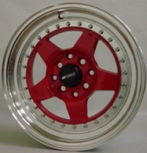

CWS779W CWS679R CWS501B IM199
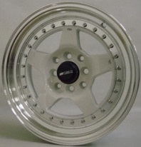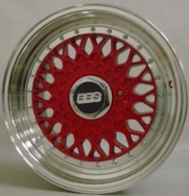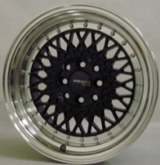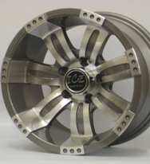
16” - 138 16”-CWS806
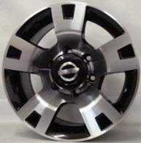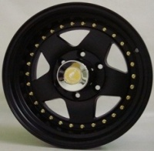

MODEL | Size | PCD & Offset | Colour Finish | Wheel Price | Combo Price
GA 068 | 15 / 6.5J | 5x100 / 5x114 (Multi PCD ) - 35 | Hyper Black | R2650 per set | R4650 per set
GA 138 | 15 / 6.5J | 4x100 / 4x108 (Multi PCD) - 35 | Silver / polished lip | R2700 Per set | R4700 per set
GA 169 | 15 / 6.5J | 4x100 / 4x114 (Multi PCD) - 35 | Black / polished face | R2750 Per set | R4750 per set
GA 170 | 15 / 6.5J | 4x100 / 4x114 (Multi PCD) - 35 | Black / polished face | R2700 Per set | R4700 per set
GA 171 | 15 / 6.5J | 4x100 PCD - 35 | Black / polished face | R2700 Per set | R4700 per set
GA 172 | 15 / 6.5J | 5x100 / 5x114 (Multi PCD ) - 35 | Black / polished face | R2700 Per set | R4700 per set
GA 173 | 15 / 6.5J | 4x100 PCD - 35 | Gunmetal / polish face | R2700 Per set | R4700 per set
GA 199 | 15 / 6.5J | 5x100 PCD - 35 | Black / polished face | R2700 Per set | R4700 per set
GA 303 | 15 / 6.5J | 4x100 / 4x114 (Multi PCD) - 35 | Black / polished face | R2650 Per set | R4650 per set
GA 1109 | 15 / 6.5J | 4x100 / 4x114 (Multi PCD) - 35 | Matt Black / Polished Face | R2750 Per set | R4750 per set
GA 1132 | 15 / 6.5J | 5x100 / 5x114 (Multi PCD ) - 38 | Black / polished face | R2650 Per set | R4650 per set
GA 1141 | 15 / 6.5J | 5x100 / 5x114 (Multi PCD ) - 38 | Black / polished face | R2650 Per set | R4650 per set
GA 1178 | 15 / 6.5J | 4x100 PCD - 35 | Matt Black / Polished Face | R2750 Per set | R4750 per set
GA 1180 | 15 / 7J | 6x139 – 0 | Gunmetal / polish face | R3400 Per set | /
EMR 521 | 15 / 7J | 6x139 – 0 | Black with polish silver | R3800 Per set | /
EMR 522 | 15 / 7J | 6x139 – 0 | Black with polish silver | R3800 Per set | /
QS20F | 15 / 7J | 4x100 / 4x114 - 38 | Red / Gold – Polished Dish | R3100 Per Set | R5100 Per Set
QS5037S | 15 / 7J | 4x100 / 4x114 (Multi PCD) - 20 | Orange/ Blue / Yellow | R3100 Per Set | R5100 Per Set
QS5612 | 15 / 7J | 4x100 / 4x114 (Multi PCD) - 30 | Blue – Polished Dish | R3100 Per Set | R5100 Per Set
QS028 | 15 / 7J | 4x100 / 4x114 (Multi PCD) - 20 | Blue / Red – Polished Dish | R3100 Per Set | R5100 Per Set
QS5037F | 15 / 7J | 4x100 / 4x114 (Multi PCD) - 38 | Silver / Red – Polished Dish | R3100 Per Set | R5100 Per Set
QS5037F | 15 / 7J | 4x100 / 4x114 (Multi PCD) - 20 | Gold – Polished Dish | R3100 Per Set | R5100 Per Set
309 | 15 /6.5J | 4x100 / 4x114 (Multi PCD) - 38 | Black with polish silver | R3000 Per Set | R5000 Per Set
308 | 15 /6.5J | 4x100 / 4x114 (Multi PCD) - 38 | Black with polish silver | R3000 Per Set | R5000 Per Set
CWS679SG | 15 / 7J | 4x100 / 4x114 (Multi PCD) - 35 | Silver - polish & gold studs | R3400 Per Set | R5350 Per Set
CWS679S | 15 / 7J | 4x100 / 4x114 (Multi PCD) - 35 | Silver - Polished Dish | R3350 Per Set | R5300 Per Set
CWS679BG | 15 / 7J | 4x100 / 4x114 (Multi PCD) - 35 | Black - polish & gold studs | R3400 Per Set | R5350 Per Set
CWS779S | 15 / 7J | 4x100 / 4x114 (Multi PCD) - 35 | Silver - Polished Dish | R3350 Per Set | R5300 Per Set
CWS779R | 15 / 7J | 4x100 / 4x114 (Multi PCD) - 35 | Red - Polished Dish | R3350 Per Set | R5300 Per Set
CWS779W | 15 / 7J | 4x100 / 4x114 (Multi PCD) - 35 | Silver - Polished Dish | R3350 Per Set | R5300 Per Set
CWS679SG | 15 / 8J | 4x100 / 4x114 (Multi PCD) - 35 | Red - Polished Dish | R3500 Per Set | R5400 Per Set
CWS501B | 15 / 8J | 4x100 / 4x114 (Multi PCD) - 20 | Black - Polished Dish | R3500 Per Set | R5400 Per Set
CWS501R | 15 / 8J | 4x100 / 4x114 (Multi PCD) - 20 | Red - Polished Dish | R3500 Per Set | R5400 Per Set
IM199 | 15/7J | 6x139.7 | Silver | R3400 Per Set | /
138 | 16 / 8.5J | 6x139.7 – 20 | Silver | R4300 Per Set | /
CWS806 | 16 / 8.5J | 6x139.7 – 0 | Black with gold studs | R4500 Per Set | /
All 15” wheel combo’s supplied with a set of 195/50/15” Tyres (Other Tyre options available at added fee.)

17” Wheels
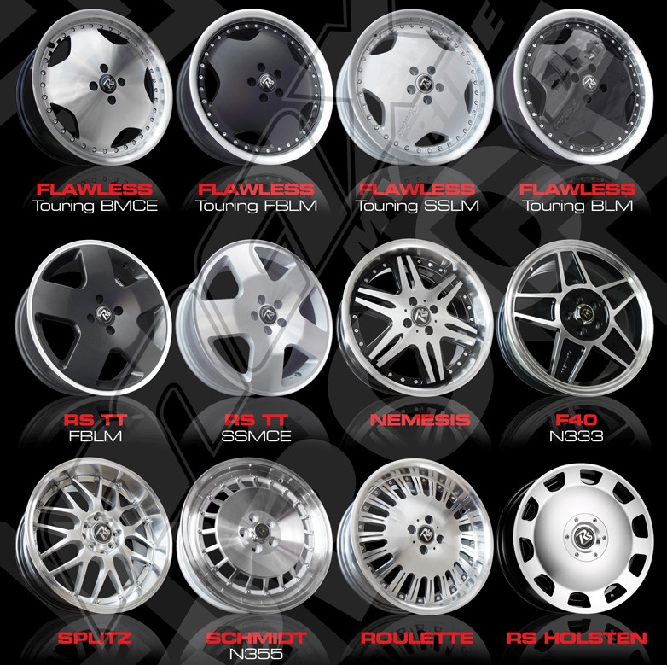
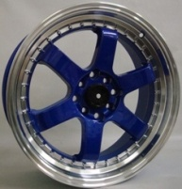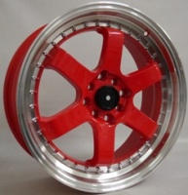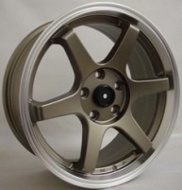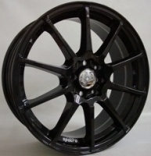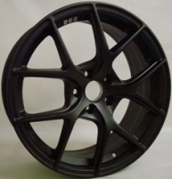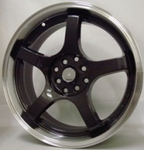
QS7612 QS7612 QSTE37 QS021S QS7022 QSTC3
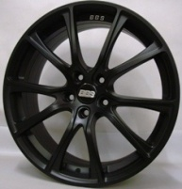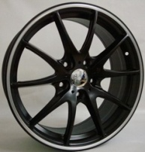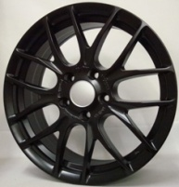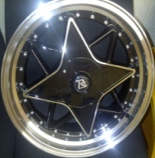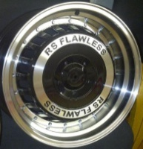
QS7030 QSG25 QS7023 GA1205 GA1204 R50
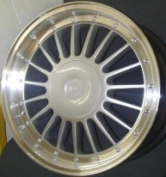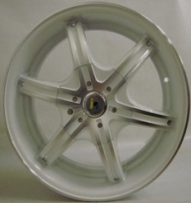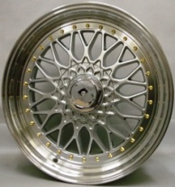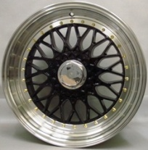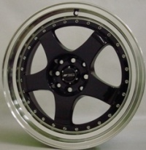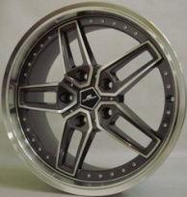
Alpina 906 CWS679SG CWS679BG CWS579 319
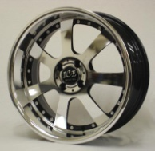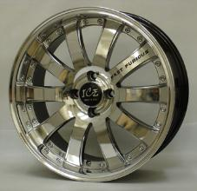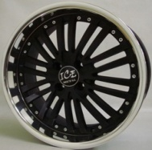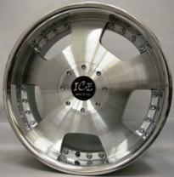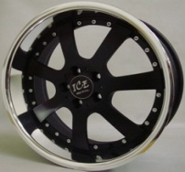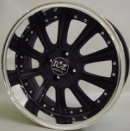
IM175S IM195 IM216 IM210 IM175B IM225

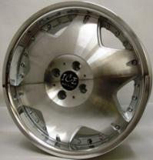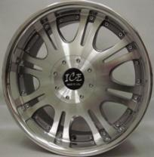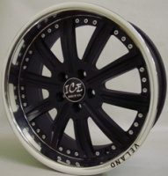
IM135 IM173 IM226
MODEL | Size | PCD & Offset | Colour Finish | Wheel Price | Combo Price
N333 – F40 | 17 / 7J | 4x100 / 5x100 - 35 | Black - Polished face | R3000 per set | R5300 per set
N355 – Schmidt | 17 / 7J | 4x100 / 5x100 - 35 | Silver - Polished Dish | R3000 per set | R5300 per set
W945 – Roulette | 17 / 7J | 4x100 / 5x100 - 40 | Silver - Polish Dish (N&W) | R4450 per set | R6700 per set
W938 - Splitz | 17 / 7J | 4x100/114 / 5x100/114 - 40 | Silver / Black - Polish Dish (N&W) | R4450 per set | R6700 per set
Nemesis | 17 / 7J | 4x100/114 / 5x100/114 - 35 | Silver - Polish Lip (N&W) | R4450 per set | R6700 per set
GA1202 -Holsten | 17 / 7J | 4x100/114 / 5x100/114 - 35 | Silver | R4350 per set | R6600 per set
EMR460-Flawless | 17 / 7J | 4x100 / 5x100 - 35 | Full Machine / Silver / Matt Black / Black Gloss | R4350 per set | R6600 per set
EMR461-RS TT | 17 / 7J | 4x100 / 5x100 - 35 | Full Machine / Black Gloss | R4350 per set | R6600 per set
QS7612 | 17 / 7J | 4x100/114 - 33 | Blue / Red – Polished Dish | R4250 per set | R6500 per set
QSTE37 | 17/7.5J | 5x114 - 35 | Bronzed Grey – Polished Dish | R4250 per set | R6500 per set
QS021S | 17 / 7J | 4x100/114 – 40 | Black | R4250 per set | R6500 per set
QS7022 | 17 / 7J | 5x100 - 40 | Black | R4250 per set | R6500 per set
QSTC3 | 17/7.5J | 4x100/114 – 38 | Black – Polished Dish | R4250 per set | R6500 per set
QS7030 | 17 / 7J | 5x114 - 40 | Black | R4250 per set | R6500 per set
QSG25 | 17 / 7J | 5x114 - 38 | Black – Silver Lip | R4250 per set | R6500 per set
QS7023 | 17 / 7J | 5x114 - 40 | Black | R4250 per set | R6500 per set
GA1205 - Ninja | 17/ 7J | 4x100/114 / 5x100/114 - 35 | Black - Polish Lip | R4350 per set | R6600 per set
GA1204-Samurai | 17/7J/7.5J | 4x100/114 / 5x100/114 – 35 /30 | Black - Polish Lip (N&W) | R4350 per set | R6600 per set
R50 | 17” / 7J | 4x100/114 / 5x100/114 - 35 | Black & Silver - Polish Lip | R4600 per set | R6800 per set
ALPINA | 17/7J/7.5J | 4x100/114 / 5x100/114 – 35 /30 | Silver – Polished Lips (N&W) | R4600 per set | R6800 per set
906 | 17 / 7J | 4x100/114 – 40 | White with silver edges | R4250 per set | R6500 per set
CWS679SG | 17/7.5J/8.5J | 4x100 / 5x100- 35/29 | Silver - polish & gold studs (N&W) | R4600 per set | R6800 per set
CWS679SG | 17/7.5J/8.5J | 4x100 / 5x100- 35/29 | Silver - polish & gold studs (N&W) | R4600 per set | R6800 per set
CWS579 | 17/7.5J | 4x100/114 – 40 | Black – Polished Dish | R4450 per set | R6700 per set
319 | 18/8J | 5x120 – 35 | Silver & Grey – Polished Lip | R4800 per set | /
IM175S | 17/7.5J | 4x100 | Full Polished (N&W) | R4350 per set | R6600 per set
IM195 | 17/7.5J | 4x100 | Full Polished (N&W) | R4350 per set | R6600 per set
IM216 | 17/7.5J | 4x100 | Black – Polished Lip (N&W) | R4350 per set | R6600 per set
IM210 | 17/7.5J | 4x100/108/114 | Silver – Polished Lip (N&W) | R4350 per set | R6600 per set
IM175B | 17/7.5J | 5x100 | Black – Polished Lip (N&W) | R4350 per set | R6600 per set
IM225 | 17/7.5J | 4x100 | Black – Polished Lip (N&W) | R4350 per set | R6600 per set
IM135 | 17/7.5J | 4x100 | Silver – Polished Lip | R4350 per set | R6600 per set
IM173 | 17/ 7.5J | 4x100/114 - 33 | Silver – Polished Lip (N&W) | R4350 per set | R6600 per set
IM226 | 17/7.5J | 5x100 | Black – Polished Lip (N&W) | R4350 per set | R6600 per set
All 17” wheel combo’s supplied with a set of 205/40/17” Tyres (Other Tyre options available at added fee.)

18” Wheel

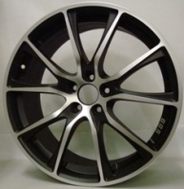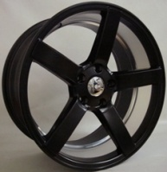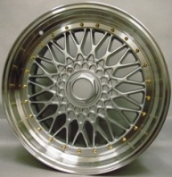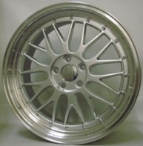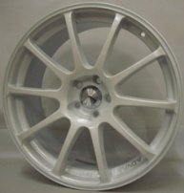
QS8022 QS8033 VOSSEN CWS679 901 BBS LM QS833
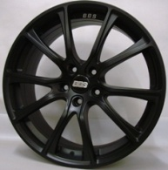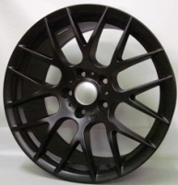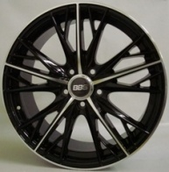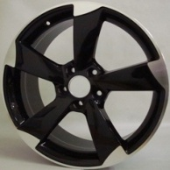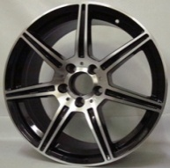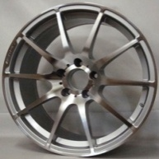
QS8030 R196 480 R217 225 1127
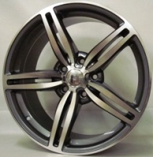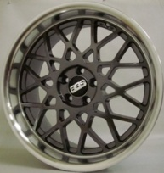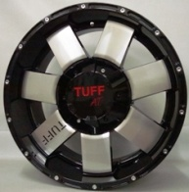
305 CWS336 711
QS8022 | 18” / 8J | 5x114 - 40 | Black | R5550 per set | R8650 per set
QS8033 | 18” / 8J | 5x100 - 45 | Silver – Black Inner | R5550 per set | R8650 per set
VOSSEN | 18/8J/9J | 5x114 – 38/ 5x114 - 40 | Black - Polish Dish (N&W) | R6200 per set | R9800 per set
CWS679 | 18 / 8.5J | 5x100/5x114 – 35 | Silver – Polished Dish | R6000 per set | R9200 per set
901 BBS LM | 18/8J/9J | 5x100 – 35 / 2 step dish | Silver – Polished Dish (N&W) | R6000 per set | R9650 per set
901 BBS LM | 18/8J/9J | 5x120 – 35 / 40 - 2 step dish | Silver – Polished Dish (N&W) | R6000 per set | R9650 per set
QS833 | 18 / 8J | 5x100 - 40 | Silver – Black Inner | R5550 per set | R8650 per set
QS8030 | 18 / 8J | 5x108 - 40 | Black | R5550 per set | R8650 per set
R196 | 18/8J/9J | 5x120 – 35 / 5x120 / 40 | Black (N&W) | R5550 per set | R9200 per set
480 | 18 / 8J | 5x112 – 40 | Black & Silver | R5550 per set | R8650 per set
R217 | 18 / 8J | 5x112 – 45 | Black & Silver | R6000 per set | R9000 per set
225 | 18/8J/9J | 5x112 – 40 | Silver – Black Inner (N&W) | R6000 per set | R9650 per set
1127 | 18/8J/9J | 5x112 – 35 | Silver (N&W) | R6000 per set | R9650 per set
305 | 18 / 8.5J | 5x120 – 35 | Silver | R6000 per set | R9200 per set
CWS336 | 18 / 8.5J | 5x100 - 35 | Silver / Grey – Polished Lip | R6000 per set | R9200 per set
711 | 18 / 8.5J | 6x139.7 – 20 | Silver & Black | R6800 per set | /
All 18” wheel combo’s supplied with a set of 225/40/18” Tyres / Staggered sets (N&W) supplied with 245/40/18” Tyres for rears. 5x120PCD staggered suppiedd with 255/35/18” Tyres (Other Tyre options available at added fee.)

19” Wheel
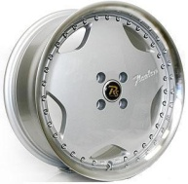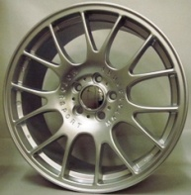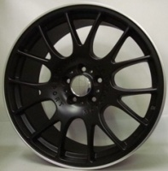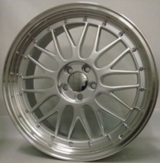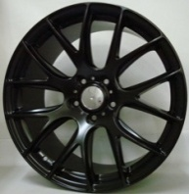
EMR460 908 908 901 QS710
EMR460-Flawless | 19” / 8J | 5x112 / 5x120 - 38 | Silver polished lip | R5500 per set | R9400 per set
908 BBS M/sport | 19”/8.5J | 5x112 - 45 | Silver or Black | R6700 per set | R10750 per set
901 BBS LM | 19”/8.5/9.5J | 5x112 – 45 / 2 step dish | Silver polished lip (N&W) | R6700 per set | R11300 per set
QS710 | 19”/8.5/9.5J | 5x120 – 35 / 40 | Black | R6700 per set | R11300 per set
All 19” wheel combo’s supplied with a set of 235/35/19” Tyres / Staggered sets supplied with 265/30/19” Tyres for rears. (Other Tyre options available at added fee.)

20” & 22” Wheel
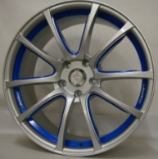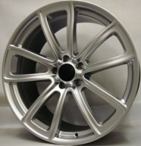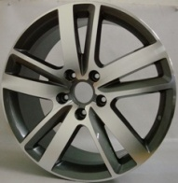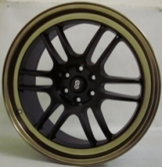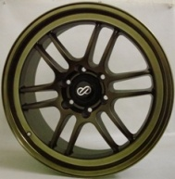
CWS306 QS021 921 R283 RPF1 RPF516
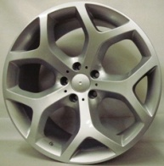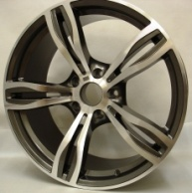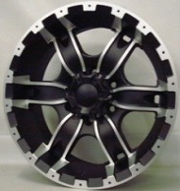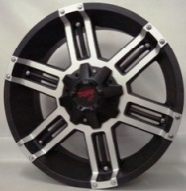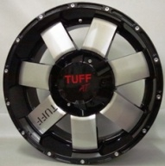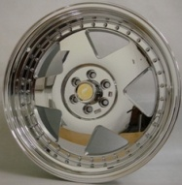
332 957 307 609 711 CWS806CR
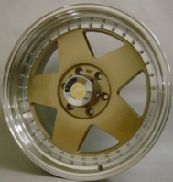
CWS806G
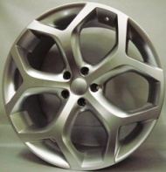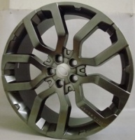
R185-22” R214-22”
CWS 306 | 20 /8.5/10J | 5x120 – 38 / 2 step dish | Silver polished lip (N&W) | R7250 per set | /
CWS 306 | 20/8.5/10J | 5x120 – 18 &25 / 2 step dish | Silver polished lip (N&W) | R7250 per set | /
QS021 | 20 / 8.5J | 5x120 – 35 | Silver | R7250 per set | /
921 | 20/9.5J | 5x112 – 35 | Silver | R7250 per set | /
R283 | 20 /9J | 5x130 – 60 | Silver | R8250 per set | /
RPF1 | 20 /9J | 6x114.3 - 30 | Black Center with Gold Lip | R8250 per set | /
RPF1 | 20 /9J | 6x139.7 - 30 | Black Center with Gold Lip | R8250 per set | /
332 | 20/9.5J/11J | 5x120 – 45 / 30 | Silver | R8250 per set | /
957 | 20/8.5/9.5J | 5x120 – 37 | Silver | R8250 per set | /
307 | 20/9J | 6x139.7 - 15 | Black with Silver | R9500 per set | /
609 | 20/9J | 6x139.7 - 20 | Black with Silver | R9500 per set | /
711 | 20/9J | 6x139.7 - 20 | Black with Silver | R9500 per set | /
CWS806CR | 20/9J | 6x114.3 / 6x139.7 - 20 | Chrome with Polished Lip | R11000 per set | /
CWS806G | 20/9J | 6x139.7 - 20 | Gold with Polished Lip | R11000 per set | /
R185 | 22 / 10J | 5x120 – 35 | Silver | R9000 per set | /
R214 | 22 / 10J | 5x120 – 35 | Silver | R9500 per set | /
Please contact us for Various tyre options.

*- For Security reasons, Please note that an order must be placed first prior to any collections & also that we do require a 50% EFT Transfer on the total amount as a deposit before we continue with any order. The balance can be paid upon collection. An Added fee will be charged on collections or delivery for any cash deposits made into our account. No tyres will be available without the above being adhered to.

NAZ KAR 13 Performance Wheel & Tyre CC
CC – 2007/065003/23
Wholesale Tyres Direct to Public.
Cell – +27 (0)81 337 0022 / +27 (0)76 962 9786
Fax – +27 (0)86 564 3194
Email : Nazkar13@gmail.com
www.nazkar13.co.za
Facebook – Naz Kar 13 Performance Wheel & Tyre CC

The Direct, Cheaper & Safer Tyre Supplier!
(Please feel free to enquire, about any tyre you may require.)

